Sheffield Hallam - Inclusive Practice Research

# Introduction

Disabled Student Support (DSS) wanted to work more collaboratively with students and the Students Union to understand the perceptions of inclusive practice and the discrepancy between the number of students sharing a disability at application and enrolment and the number of students supported with a learning contract. Following feedback from previous surveys, the research aimed to consider streamlining the learning contract, considering the naming of the document used for reasonable adjustments, improving implementation, and agreeing on some Baseline Inclusive Measures (BIMS) across the university to improve consistency and equity of experience for students.

# Research

The research focused on perceptions of inclusive practice, the provision of a learning contract for reasonable adjustments, and the proposal for inclusive baseline standards. The project had ethical approval granted, and focus groups were held in December 2023. Forty students were invited after promotion through the Disabled Student Support annual survey and direct marketing through the Students Union. Twenty-one disabled and non-disabled students participated in the three focus groups delivered on and off campus.

Focus group 1 was an in-person session with eight attendees; 3 students self-identified as disabled, there was an equal mix of male and female attendees from each college, a mix of ethnicities, and two international students. The second and third focus groups were delivered online; one was a mix of disabled (2) and non-disabled students (5), and the final focus group was all disabled students (6). The rationale for including non-disabled students was that many do not consider themselves disabled but would be eligible for support. Also, inclusive practice benefits not only disabled students but all students.

The data was coded using thematic analysis with pre-defined codes agreed on after the first read-through of the transcripts created with colleagues from the Student Union. Meta themes were then discussed, following detailed coding by the researchers. The main themes resonate with the findings from the Disabled Student Support survey, particularly in terms of communication and awareness of learning contracts and the support available, as well as the importance of implementing recommendations. The main themes identified were Communication, Responsibility, Implementation, and Trust.

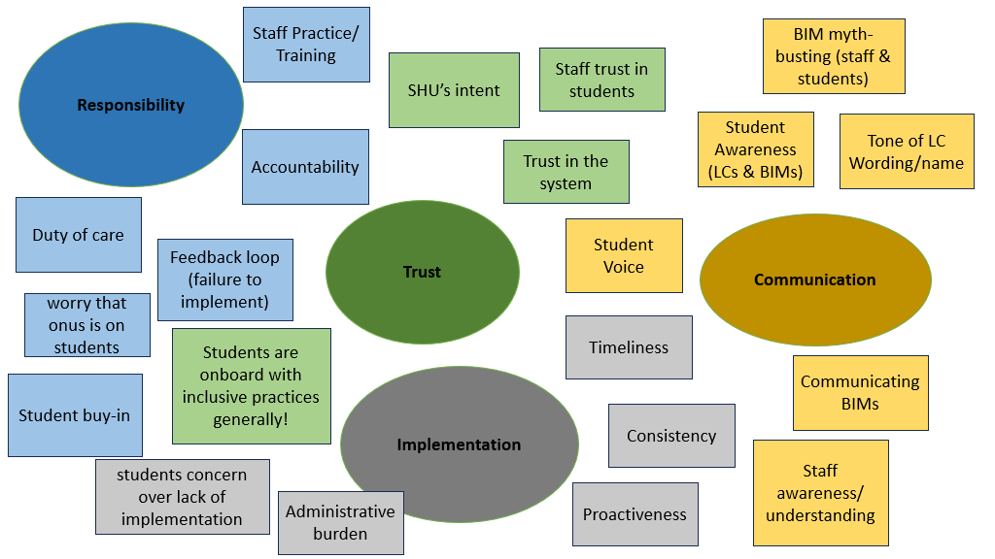

Figure 1 - Visualisation of themes

# Findings

## Perception of Inclusive Practice

The sessions all began with a question about what inclusivity meant to the participants. Students gave various answers but all around the same themes, making people feel included, that **‘Hallam is a place for everybody,** ' that everything is accessible, and that there ‘**is equal access and opportunity’** and **‘equity.’** However, some participants mentioned that some students may need additional support or help to achieve their best, so not everything is equal.

## Communication

Communication was a central theme throughout the focus groups. Sub-themes included awareness of the learning contract and support available, sharing of information, naming the learning contract, the complexities of language, and the tone and meaning of recommendations in the learning contract.

Firstly, not all participants knew about the learning contract at Sheffield Hallam, what it was, how you got one, and why it would be helpful. One participant mentioned that many students asked her about her support personally. Another participant said that they were struggling badly and had feedback from academics to seek support, and that was how they learned about learning contracts. Participants felt that regular signposting and further explaining and advertising of the support offer was needed to ensure that students knew what resources were available. This would need to be done often and in a variety of methods.

**“ it’s important to let them [students] know that there is more support out there if people need it. Because … if you need more support, then you can access more.”**

Participant Focus Group 3

Students who have shared a disability on their UCAS form will be sent information as applicants about the support available and invited to a Study Ready session during the summer to hear about the institutional and inclusive support available and the government-funded support through Disabled Students Allowances. Students are also asked at enrolment if they want to share a disability and are invited to register with Disabled Student Support. Disability information is also shared through Hallam Welcome. The service has reduced as many barriers as possible to the service and now requests students to complete a short registration form and, if possible, provide any disability evidence. The thresholds for evidence have been reduced away from the DSA-funded standards and more to the Equality Act definition of ‘significant impact’ and ‘likely to last more than 12 months’.

**Recommendation 1: Review the communications about disability and inclusive support at Hallam and develop a communication plan.**

Participants who had a learning contract mainly reported positive experiences, and those who had applied and were awarded funded support through the government's Disabled Students Allowances (DSA) had great support from early in their course. Students felt that the process had allowed them to have some agency in producing the learning contract and that they approved what would be shared. There was some discussion around sharing the learning contract and a lack of understanding of how the process worked and who could see the information. This lack of awareness did cause some concern about whether students would want to come forward for this type of support and the implications. Students also reported issues accessing the Learning Contract themselves as they were unsure how to locate it and which system it was in.

**“people are put off getting learning contracts because they are quite invasive in some regard with the whole data and who can access it and stuff.”**

Participant Focus Group 1

Interestingly, in addition to the concern about data sharing, participants also mentioned that the name was off-putting and that they were unclear about what the Learning Contract meant, that it was too formal, and didn’t adequately explain what it was for or how it was used. Participants recognised that it was a difficult task to name the document. However, terms such as **‘Learning Agreement’** and **‘Adjustment Plan’** were suggested in the focus groups as they felt more collaborative than contract, which participants felt meant that it could not be reviewed or adjusted and had been imposed on students.

The tone of the Learning Contract was also discussed with participants, who stated that the overall tone was unhelpful and not very warm. The participants felt that there was a lot of responsibility on students, and the wording was a bit aggressive, which could cause more stress.

There could be some confusion over this as there are two views, a student view and a staff view of the learning contract, which the group facilitators and participants were unaware of and perhaps staff generally are unaware of. It was recommended that the document should have more support information, not highlight **‘what is wrong with you but what support is available’** but not a lot of links, and the language could be softened. In addition, a better understanding of how the learning contract should be implemented and the practicality of this is essential.

A participant summed up a session by stating.

**“I have learned a lot from the session, and I think that the learning contract is important, yes, but the language and tone should be changed, and also their name, and also to include the other support for it to be better, yeah.”** Participant from Focus Group 2

Regarding the proposed changes to the learning contract, it was agreed that the key information about the individual’s experience of disability and its impact on teaching, learning, and assessment would be helpful and could help explain some of the reasonable adjustments and how these could be best implemented. It was also highlighted that a student's needs could change during their studies and that the learning contract should be a **‘living document’** that could be updated or changed to reflect this.

**Recommendation 2 – Rename and rebrand and relaunch the Learning Contract**

## Baseline Inclusive Measures

Regarding the Baseline Inclusive Measures (BIMs), there was resounding approval for this approach across all the focus groups, especially in focus group 3, which consisted of all disabled participants.

**“I think that it’s good that we’re kind of branching out and maybe students who don’t have learning contracts but have other issues that haven’t maybe been addressed by the university or they haven’t brought it to anyone’s attention, still have access to support and help.”**

**“they are all really relevant and really important when considering both learning contract students and those without.”**

Participants in focus group 3

A central issue that has been reported in the student survey and the focus groups is a lack of awareness of the support available. There was also uncertainty about what was currently available for all students and how this worked in practice, for example, around the extension policy. In addition to student awareness, the importance of staff awareness was also mentioned and

**“ a commitment of doing accessibility for everyone, so it’s like the culture of not only the staff but all the stakeholders to have the accessible culture”**

Participant Focus Group 1

Students who were aware of the inclusive extra time in exams understood the benefits of this approach but that it wasn’t a panacea for their experiences of disability.

**“when I was in school I hadn’t actually been diagnosed with my dyslexia, so the extra support would have been helpful to have as an overall option.”**

Participant Focus Group 3

**“the 25% extra for everybody, I know that like a lot of my friends don’t need that extra time whereas I do ….. but I need to continuously explain what’s going on with me anyway”**

Participant Focus Group 2

**Recommendation 3: Agree on the Baseline Inclusive Measures as a Hallam standard and promote this widely to staff and students for an equitable experience.**

## Implementation

One of the main themes in the research was the inconsistent implementation of reasonable adjustments and inclusive practice. For example, some students were already accessing lecture recordings within a few hours of the session, which positively impacted their learning, and other students were not getting any recordings even with a learning contract and had the additional burden of trying to organise this themselves. Some of the more explicit reasonable adjustments in the learning contract were not being implemented, such as providing accessible teaching materials, providing teaching materials and reading lists in advance, and supporting students with issues attending sessions. There was a lack of understanding of how academics are made aware of learning contracts, training to implement reasonable adjustments, disability awareness generally, and the legal duty to support disabled students.

**“I feel like it would be really helpful if they could understand why these things were so important and then it would probably be executed better.”**

Participant Focus Group 2

There is discussion about how the learning contract could support students beyond academic areas and signpost them to other forms of support. This is an interesting concept and demonstrates that being disabled isn’t limited to academic areas of a student’s life but the social and environmental aspects. This was evident in the experiences of physical accessibility and the impacts on university life when students could not access lifts and would appreciate notification when there was an issue so that it didn’t impact their attendance. There are also issues with travel between sessions, the issues this caused, and general wayfinding difficulties on campus.

Placements were another area discussed in the focus groups as it is a section in the learning contract. Generally, it was felt that there was limited information about the support available on placements, and students felt confused and passed from one place to another. One participant said she has been in touch with the placement provider, but she would have liked to have more information about the process and what support could be implemented. Students also recognised that there were placement issues and were unsure who to go to for support. Other participants have problems with sharing the learning contract as it was for academic study and would want something to support them on placement. Some students struggled with finding placements and what placement would mean in terms of support, so they would appreciate more input from the university to support them in getting this experience, which is highly valued.

**“learning contract does need to be changed and I think that more responsibility needs to be taken on by the university rather than by the students... to be improved and more focused on placements”**

Participant Focus Group 2

Participants recognised that the university was trying to improve the experience, and clear communication and guidance, as well as a discussion about the support available from the university, would be very welcome as this is a major area for a lot of students in their university journey.

**Recommendation 4: Improve the information and guidance to support students on placement.**

## Responsibility

As mentioned previously, responsibilities are mentioned several times in the research. The student's responsibilities and proactivity, the staff's responsibility and buy-in, joint decision-making, and monitoring. Students understood they needed to speak to the university for the best support. Participants felt they had to reach out a lot to ensure reasonable adjustments were implemented. At some points, participants felt this wasn’t well received by academic staff and were worried about how the relationship might be impacted or whether they would be treated or have work marked differently, even feeling that they were being punished. Participants wanted there to be conversations between course teams in the production of learning contracts. This already happens, but perhaps that isn’t always made clear to students. Participants felt that the tone of the learning contract placed a lot of responsibility on students.

**‘it’s very directive towards the student. It is a lot of ‘you should, you should’**

**“it just feels like they’re giving you more work to do to then put it in to place where what I'm seeking for is help.”**

Participants Focus Group 2

Participants felt more engaged when they could tell academics had read the learning contract; when they hadn’t, they were **‘not really being acknowledged’.** Participants felt that having a named contact from Disabled Student Support would be helpful if there was an issue in the classroom. Students are encouraged to come back to disabled student Support if they are experiencing any difficulties with the reasonable adjustments in the learning contract, either not working or not being implemented.

Again, perhaps this needs better communication about the tone of the learning contract and the responsibilities. The current Learning contract has the responsibilities of all stakeholders, but this makes for a lengthy document. However, students want to know what staff are responsible for. Students gave useful ideas for supporting implementation, such as having a list of students with learning contracts, not knowing that this is available on class lists. Participants also asked about the training provided and what would be helpful to staff and ensuring that lecturers know what they can be doing.

**Recommendation 5. Reasonable Adjustments and Inclusive Practice policy and a training program for academic staff.**

## Trust and Student Voice

Trust is a theme that runs through the focus groups. This was articulated through the reciprocity of sharing a disability and personal experiences of disability with staff and through a learning contract that this information is used to support students. Still, it could also create some vulnerability and uncertainty about implementation.

**“It’s about, I guess, feeling safe enough, brave enough, and compassionate enough spaces in order to be open about this and to have those conversations without feeling that you're taking up their time or you're being a nuisance or anything like that. It’s, I guess, fostering those spaces where you can have those conversations.”**

Participant Focus Group 3

Students felt that the process with the learning contract meant that it couldn’t be reviewed or discussed after the initial contract was drawn up. Perhaps due to the name and the word ‘contract,’ it felt fixed and immutable. However, the learning contract can be amended and updated, and there is version control. The main reason for wanting more checking in was the lack of understanding about what support was needed, especially at the beginning of the course; they weren’t sure what they needed or what would work. They also wanted a route to say when adjustments weren’t being implemented, or there were other issues. Participants wanted to know that they could trust staff to receive and read the learning contract and that it would be implemented.

**“if I'm putting myself in to something then I want to know it’s being reciprocated back, so yeah, and I know if I have a bad day the university has got my back**.”

Participant Focus Group 1

The focus groups were well received and appeared to have positively impacted the attendees. It raised awareness of the inclusive practice and the support available, as well as allowing students to be involved with the future support mechanism at the point of design.

**“so final thoughts I would say that first of all it’s great that the university is getting us to have these discussions because there is always going to be like something that people want to share, because the environment is always changing and I think that we need to take in to consideration all aspects of university life and how accessible they may be.**

Participant Focus Group 2

**Recommendation 6 – Create a disabled student panel to run throughout the year and create a more inclusive and collaborative feedback loop.**

# Conclusion and recommendations

It was a positive experience to involve students in the review of the learning contract. Many of the themes are echoed in the disabled student support survey, and there are some easily identifiable recommendations. The next step is to provide feedback on the project and improve the student experience.

* **Recommendation 1: Review the communications about disability and inclusive support at Hallam.**
* **Recommendation 2 – Rename and rebrand and relaunch the Learning Contract**
* **Recommendation 3: Agree on the Baseline Inclusive Measures as a Hallam standard and promote this widely to staff and students for an equitable experience.**
* **Recommendation 4: Improve the information and guidance to support students on placement.**
* **Recommendation 5. Reasonable Adjustments and Inclusive Practice policy and a training program for academic staff.**
* **Recommendation 6 – Create a disabled student panel to run throughout the year and create a more inclusive and collaborative feedback loop.**